**ELECTORAL BONDS REPORT(2019-2024)**

**Electoral Bonds:**

Electoral bonds are a financial instrument for making donations to political parties. These are issued by a scheduled bank (SBI in this case) and can be bought by any Indian citizen or company.

**Release of Electoral Bonds by ECI and SBI:**

The ECI uploaded data on electoral bonds received from the SBI on its website. This was in compliance with a Supreme Court order. The SBI had requested an extension until June 30, 2024, to provide information regarding Electoral Bonds to the ECI. However, the SBI disclosed all details of the electoral bonds which are in its possession and custody to the ECI on March 21, 2024.

**Data in the Released Sheets:**

The released data includes various details about the electoral bonds:

- **Date of issuance** of the electoral bonds

- **Denomination of funds**

- **Number of bonds**

- Issuing **SBI branch**

- **Dates of receipt** and credit at the parties' bank accounts

- **Redemption particulars** of political parties, including serial numbers, encashment dates, party names, the last four digits of account numbers, prefixes, bond numbers, denominations, pay branch codes, and pay tellers.

The data allows for the connection of the purchaser of the bond to the party that encashed it. The names of purchasers and parties involved were already released to the public on March 14, in two separate lists.

**Reports on Individual Datasets:**

**For the purchaser companies:**

This is a dataset that provides all the details of the companies that have purchased the electoral bonds from the authorized branches of State Bank of India (SBI). SBI is the sole authorized bank for issuing and redeeming electoral bonds as per the Electoral Bond Scheme introduced by the Government of India in 2018.

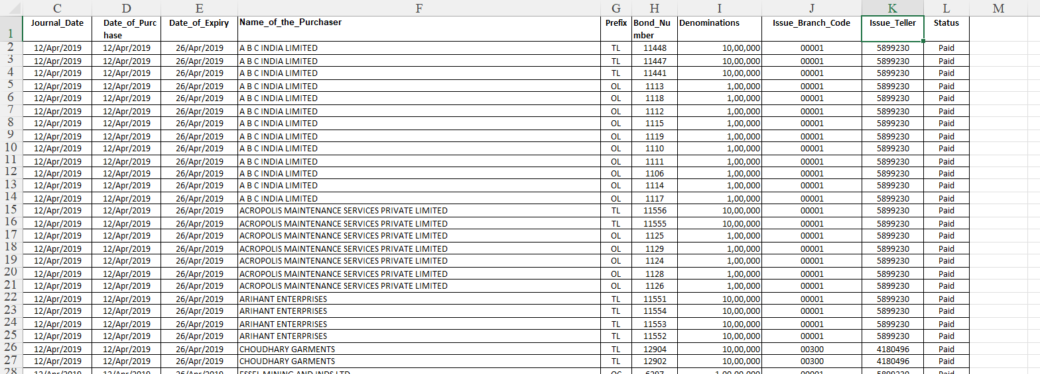

This a snapshot of our dataset, the target columns from this dataset are Name_of_the_Purchaser, Bond_Number, Denominations and Issue_Branch_Code**.**

**Report on this Dataset:**

**This code provides the no of bonds each company/purchaser has purchased.**

proc import datafile='/home/u63714413/Riya/Purchaser_Comp_All_Cols.xlsx'

out=mydata

dbms=xlsx

replace;

run;

proc freq data=mydata;

tables Name_of_the_Purchaser/ nocum nopercent missing;

run;

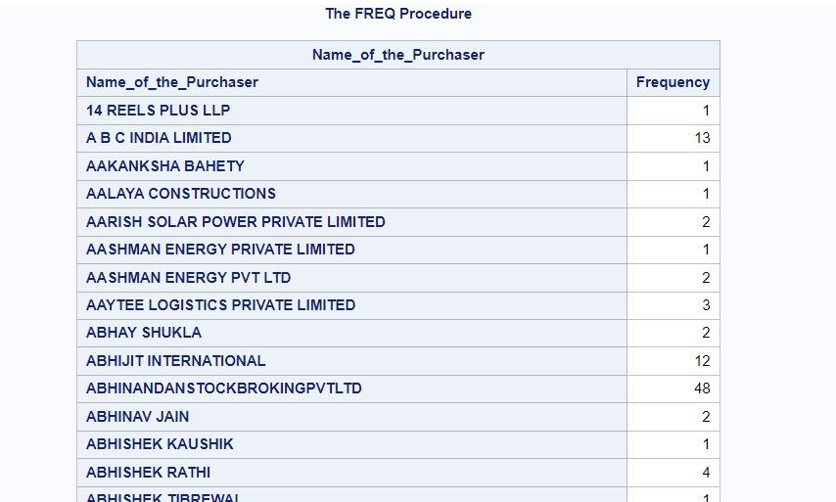

**This code gives the total amount of denominations that each purchaser gives.**

PROC FORMAT;

picture INR_FORMAT

low - 999 = '999'(prefix=' ₹' mult=1)

1000 - 9999 = '9,999'(prefix=' ₹' mult=1)

10000 - 99999 = '99,999'(prefix=' ₹' mult=1)

100000 - 999999 = '9,99,999'(prefix=' ₹' mult=1)

1000000 - 9999999 = '99,99,999'(prefix=' ₹' mult=1)

10000000 - 99999999 = '9,99,99,999'(prefix=' ₹' mult=1)

100000000 - 1000000000 = '99,99,99,999'

(prefix=' ₹' mult=1)

1000000000 - 10000000000 = '999,99,99,999'

(prefix=' ₹' mult=1)

10000000000 - high = '9999,99,99,999'

(prefix=' ₹' mult=1);

RUN;

proc sql;

create table work.Purchaser_Summary as

select Name_of_the_Purchaser as Purchaser_Name,

sum(input(Denominations, comma12.)) as Total_Denominations

from mydata

group by Name_of_the_Purchaser

order by Total_Denominations desc;

quit;

proc print data=Purchaser_Summary;

format Total_Denominations INR_FORMAT.;

title 'Purchaser Summary - Total Denominations';

run;

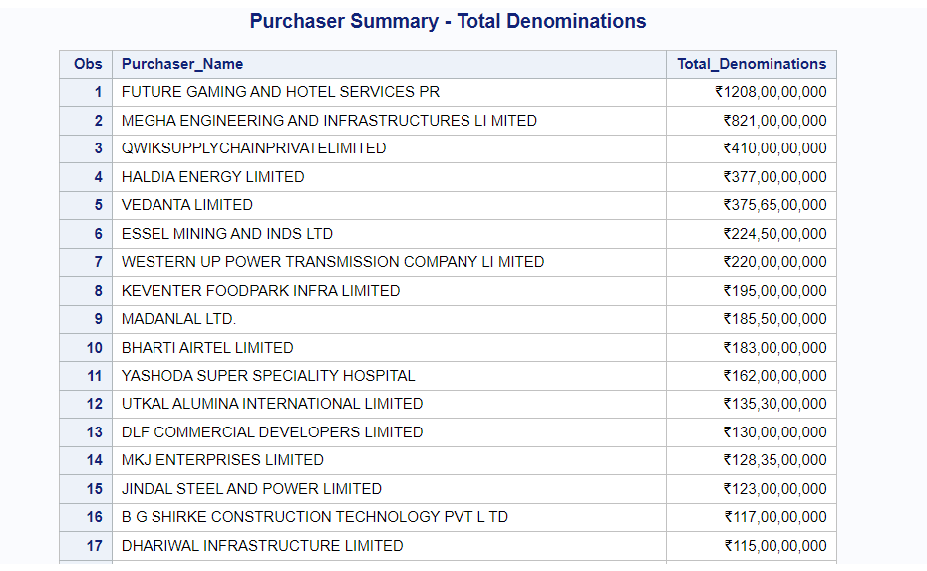

**So now we plot the top 5 purchasers of the electoral bonds:**

**First we make a new dataset in which we only store the Top 5 purchasers of the bonds by sorting them in descending order:**

proc sort data=Purchaser_Summary out=Top5Purchasers (keep=Purchaser_Name Total_Denominations);

by descending Total_Denominations;

run;

data Top5Purchasers;

set Top5Purchasers (obs=5);

run;

proc sgplot data=Top5Purchasers;

title 'Top 5 Purchasers by Total Denominations';

vbar Purchaser_Name / response=Total_Denominations datalabel;

xaxis display=(nolabel);

yaxis label='Total Denominations' grid;

run;

**Now we plot them:**

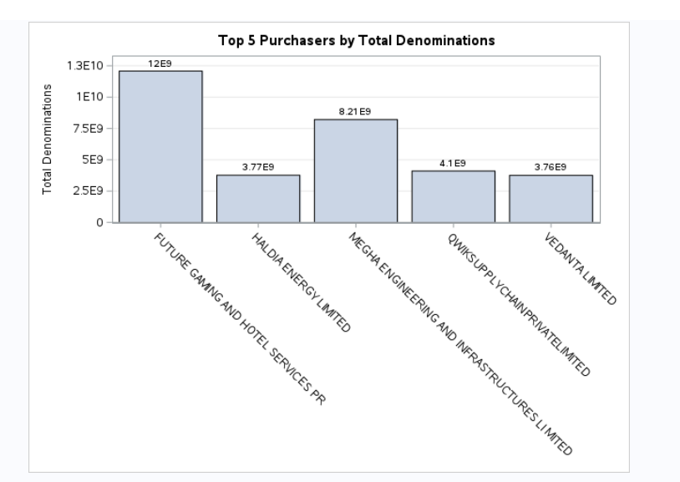

**For the redeemer parties:**

**This dataset contains information about all the parties that have redeemed the bonds issued to them by the purchaser companies through SBI.**

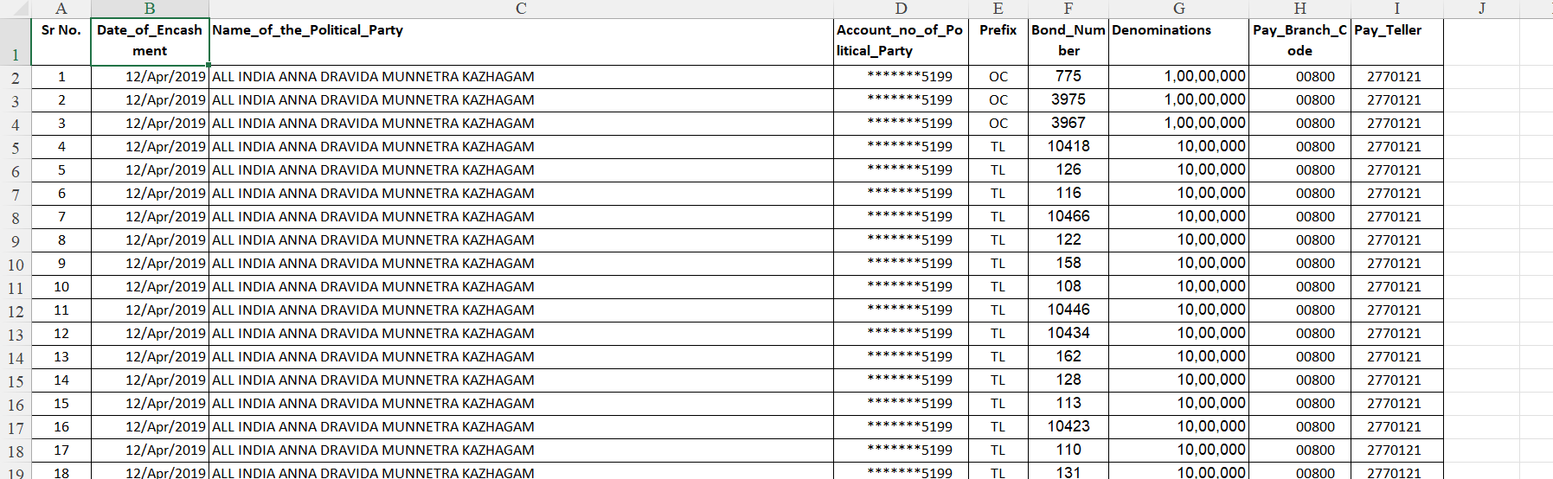

**This is a snapshot of the dataset, the target columns in this dataset are Name_of_the_Political_Party, Bond_Number, Denominations, Pay_Branch_Code.**

**Report on this Dataset:**

**This code is for importing the Reedemer file:**

proc import datafile='/home/u63714413/Riya/Reedemer_Party_All_Cols.xlsx'

out=reedemer

dbms=xlsx

replace;

run;

proc freq data=reedemer;

tables Name_of_the_Political_Party / nocum nopercent missing

out=Party_Frequency(keep=Name_of_the_Political_Party Count) ;

run;

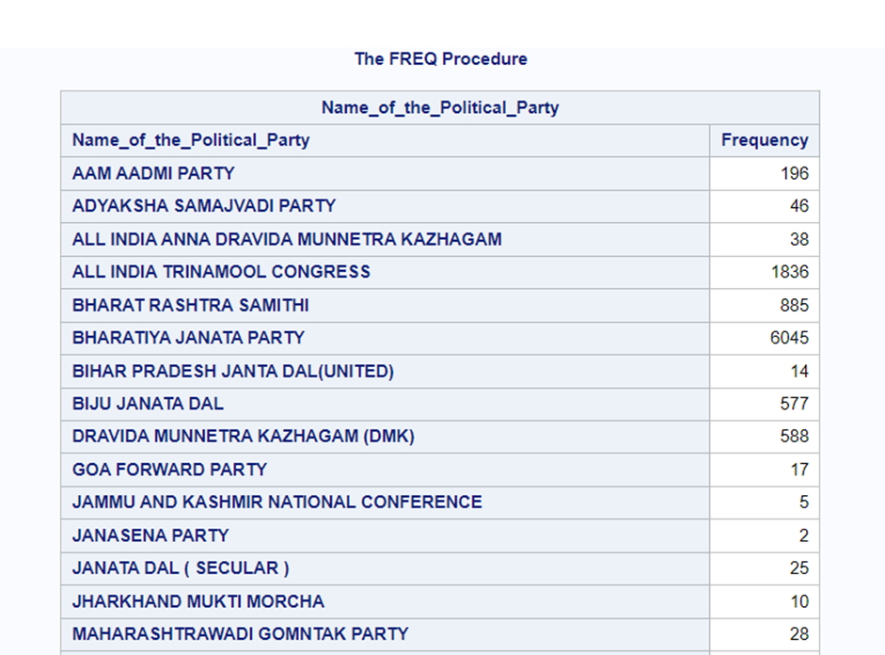

**This code counts the total number of bonds each party has gotten and is sorted.**

proc sort data=Party_Frequency;

by descending Count;

run;

proc print data=Party_Frequency;

title 'Party Bond Counts';

run;

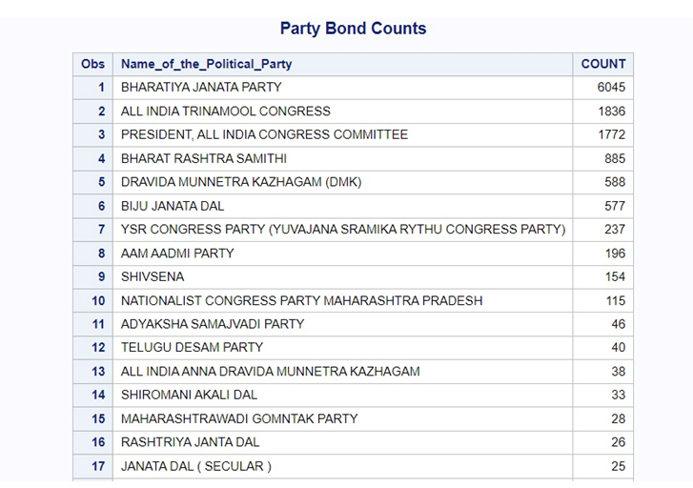

**This code plots the top 5 parties that have gotten the highest number of bonds.**

PROC SQL;

CREATE TABLE Top5Parties AS

SELECT Name_of_the_Political_Party,

Count

FROM Party_Frequency(OBS=5)

ORDER BY Count DESC;

QUIT;

proc sgplot data=Top5Parties;

vbar Name_of_the_Political_Party / response=Count

datalabel;

title 'Top 5 Parties with Highest Bond Counts';

run;

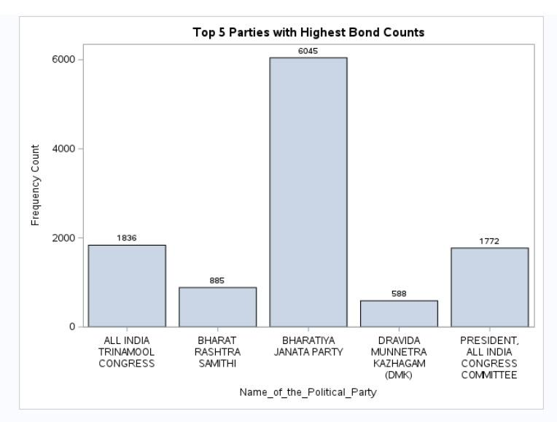

**This code shows the year wise total denominations.**

PROC FORMAT;

picture INR_FORMAT

low - 999 = '999'(prefix=' ₹' mult=1)

1000 - 9999 = '9,999'(prefix=' ₹' mult=1)

10000 - 99999 = '99,999'(prefix=' ₹' mult=1)

100000 - 999999 = '9,99,999'(prefix=' ₹' mult=1)

1000000 - 9999999 = '99,99,999'(prefix=' ₹' mult=1)

10000000 - 99999999 = '9,99,99,999'(prefix=' ₹' mult=1)

100000000 - 1000000000 = '99,99,99,999'

(prefix=' ₹' mult=1)

1000000000 - 10000000000 = '999,99,99,999'

(prefix=' ₹' mult=1)

10000000000 - high = '9999,99,99,999'

(prefix=' ₹' mult=1);

run;

data reedemer;

set reedemer;

Denominations = compress(Denominations, '.,$');

DenomNumeric = input(Denominations, comma12.);

run;

proc sql;

create table Yearly_Summary as

select year(Date_of_Encashment) as Encashment_Year format=4.,

sum(DenomNumeric) as Total_Denominations

from reedemer

group by Encashment_Year

order by Encashment_Year;

quit;

proc print data=Yearly_Summary;

title 'Yearly Summary - Total Denominations';

format Total_Denominations INR_FORMAT.;

run;

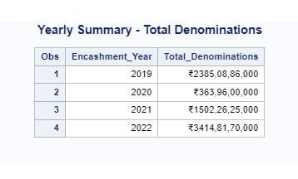

**This code plots the total denominations year wise.**

proc sgplot data=Yearly_Summary;

title 'Yearly Summary - Total Denominations';

vbar Encashment_Year / response=Total_Denominations;

xaxis label='Year' valuesformat=YEAR4.;

yaxis label='Total Denominations';

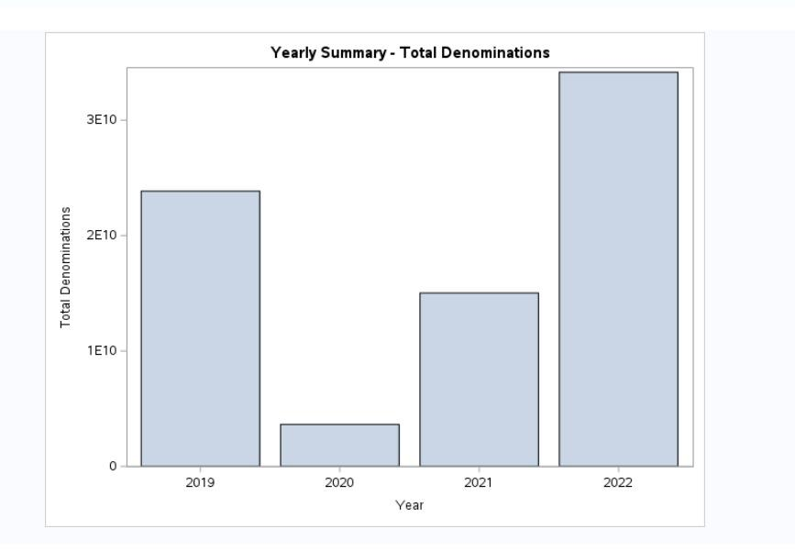

**Join of Bond Purchasing Company and the Redeeming Political Parties**

We first sort two datasets, WORK.PURCHASER_COMP_ALL_COLS and WORK.REDEEMER_PARTY_ALL_COLS, by the variable **BondNumber** and store them in temporary datasets. We then merge these sorted datasets based on the common variable BondNumber, keeping only the rows where BondNumber is present in both datasets. The merged dataset is stored in WORK.COMBINE_MATCHONLY. Finally, we delete the temporary datasets as they are no longer needed. This process allows us to combine information from two different sources into a single dataset for further analysis.

**Merging the purchaser and redeemer datasets:**

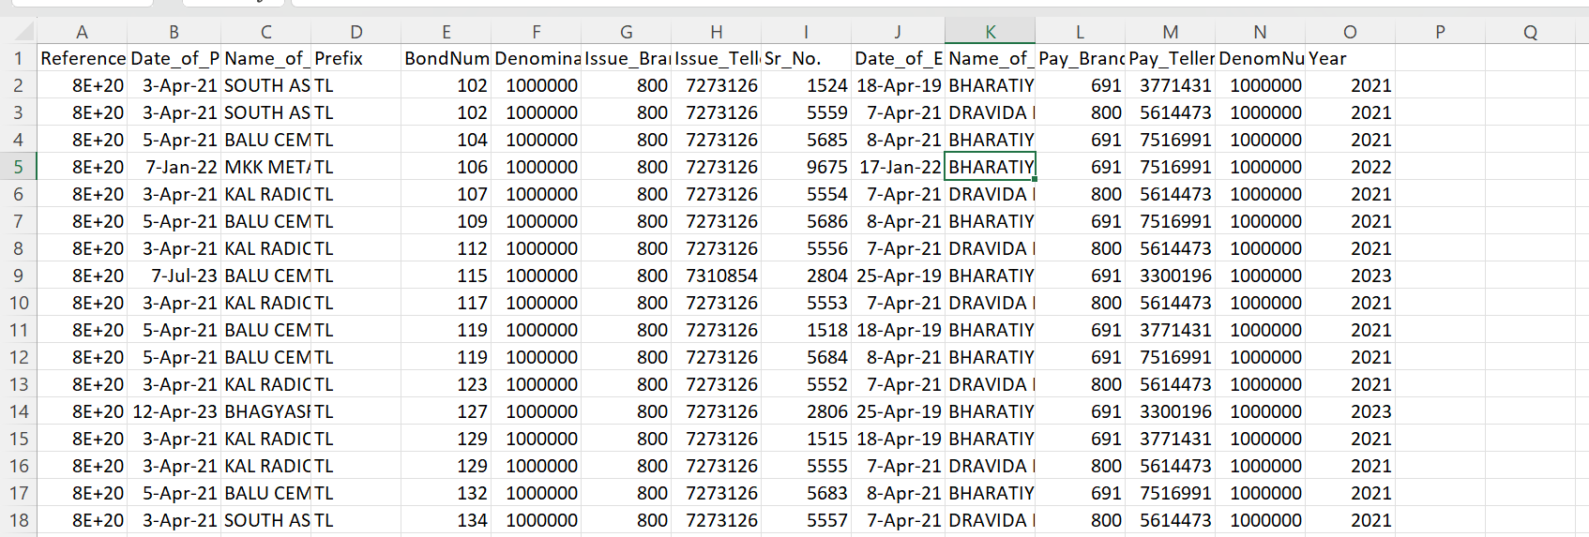

This is the combined or merged dataset, which we have made using the redeemer and purchaser datasets using Bond_Number as the primary variable used to merge the two datasets.

This The Program used to execute that

proc sort data=WORK.PURCHASER_COMP_ALL_COLS out=work._tmpsort1_;

by BondNumber;

run;

proc sort data=WORK.REDEEMER_PARTY_ALL_COLS out=work._tmpsort2_;

by BondNumber;

run;

data WORK.COMBINE_MATCHONLY;

merge _tmpsort1_(in=in1 keep='Reference_No _(URN)'n Date_of_Purchase

Name_of_the_Purchaser Prefix BondNumber Denominations Issue_Branch_Code

Issue_Teller BondNumber) _tmpsort2_ (in=in2 keep=Date_of_Encashment

Name_of_the_Political_Party 'Sr_No.'n Pay_Branch_Code Pay_Teller BondNumber);

by BondNumber;

if in1 and in2;

run;

proc delete data=work._tmpsort1_ work._tmpsort2_;

run;

proc print data=WORK.WorkingCOMBINE noobs;

var Date_of_Purchase Issue_Branch_Code Name_of_the_Purchaser Name_of_the_Political_Party DenomNumeric ;

format Date_of_Purchase ddmmyy. DenomNumeric indian_currency. ;

id BondNumber;

title "Join Of Bond Purchasing Companies and Bond Redeeming Parties";

Run;

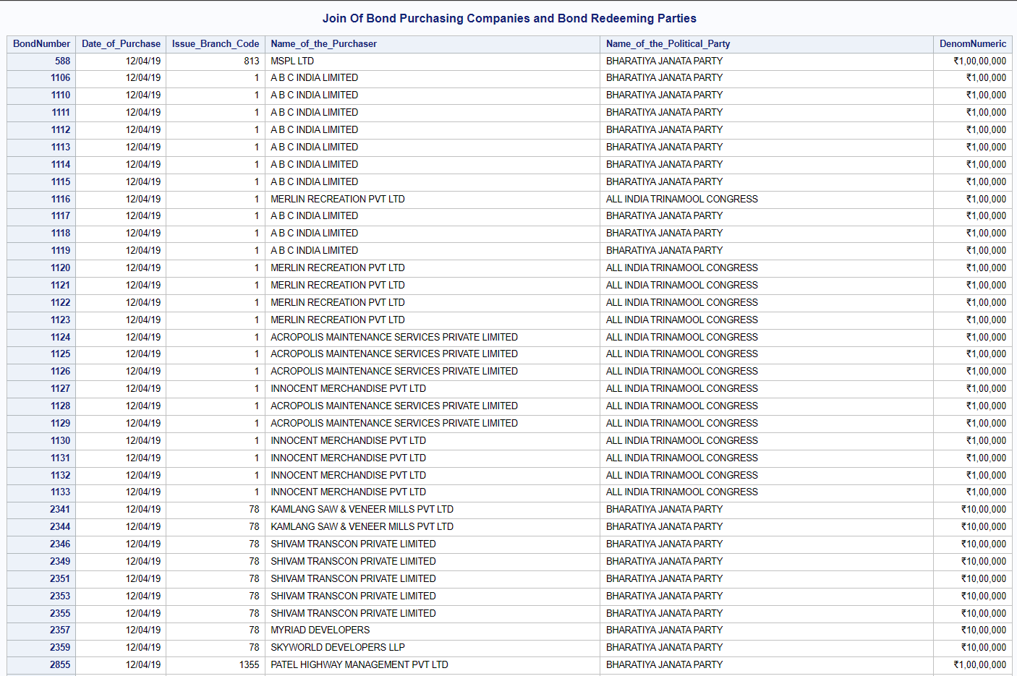

PROC SORT DATA=WORK.WorkingCOMBINE OUT=sorted_bonds;

BY Year DenomNumeric DESCENDING Name_of_the_Purchaser;

RUN;

PROC SQL OUTOBS=MAX;

CREATE TABLE top_companies AS

SELECT

Year,

Name_of_the_Purchaser,

Name_of_the_Political_Party,

SUM(DenomNumeric) AS Total_Denomination

FROM sorted_bonds

GROUP BY Year, Name_of_the_Purchaser, Name_of_the_Political_Party

ORDER BY Year, Total_Denomination DESCENDING;

QUIT;

DATA top_companies;

SET top_companies;

BY Year;

IF FIRST.Year THEN Rank=1;

ELSE Rank+1;

IF Rank <= 5;

RUN;

PROC PRINT DATA=top_companies NOOBS label;

BY Year;

VAR Rank Name_of_the_Purchaser Name_of_the_Political_Party Total_Denomination;

TITLE "Year-wise Top 5 Purchasing Companies and Redeeming Political Parties";

format Total_Denomination INR_FORMAT.;

RUN;

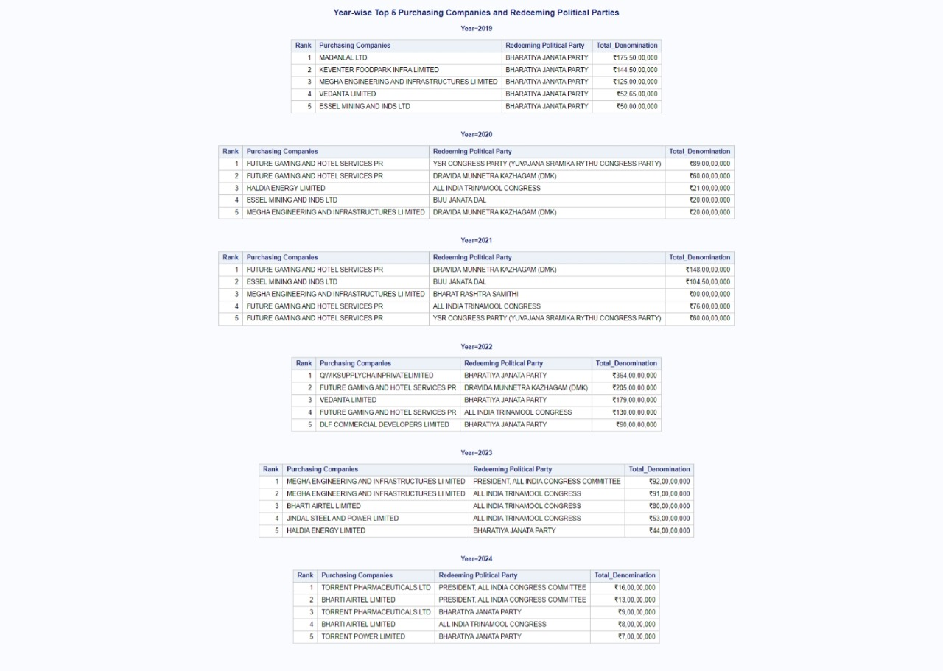

PROC SORT DATA=WORK.WorkingCOMBINE OUT=sorted_bonds;

BY Year DenomNumeric DESCENDING Name_of_the_Purchaser;

RUN;

PROC SQL;

CREATE TABLE party_report AS

SELECT

Name_of_the_Political_Party,

Name_of_the_Purchaser,

SUM(DenomNumeric) AS Total_Denomination

FROM WORK.WorkingCOMBINE

GROUP BY Name_of_the_Political_Party, Name_of_the_Purchaser

ORDER BY Name_of_the_Political_Party, Total_Denomination DESCENDING;

QUIT;

PROC PRINT DATA=party_report NOOBS label;

BY Name_of_the_Political_Party;

VAR Name_of_the_Purchaser Total_Denomination;

TITLE "Total Denominations and Associated Companies for Each Redeeming Political Party";

format Total_Denomination INR_FORMAT.;

RUN;

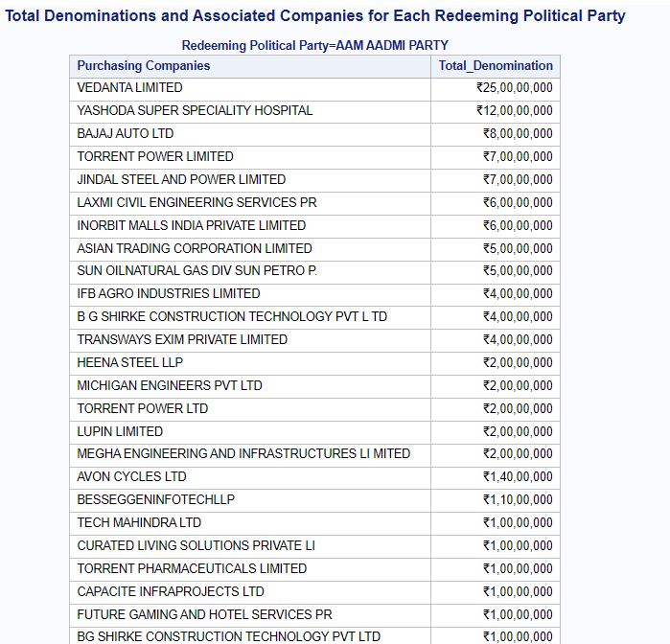

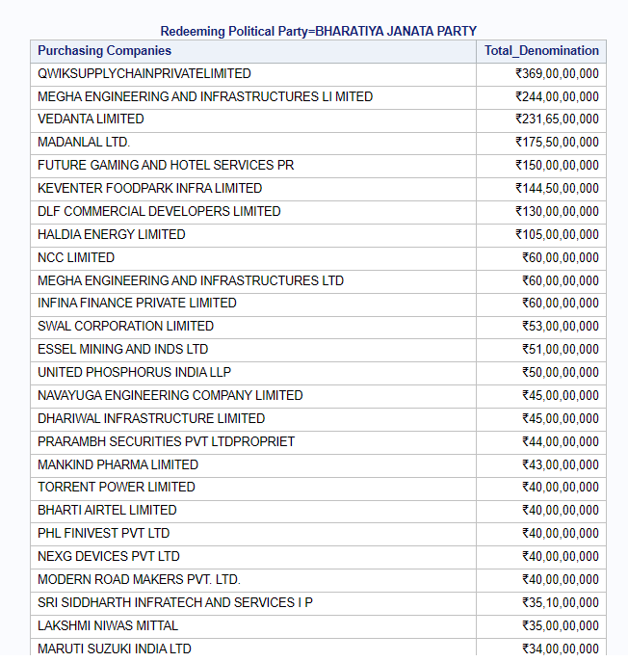

**Analysis Of Bond Issuing and Redeeming Branches of SBI**

**Here we try to Find out the most Bond issuing and redeeming bank by performing left join on the merged dataset with the Branch Code to Branch Name Data set which is missing a few entries of newer branches and other misc branches.**

**First Taking the count of variable Of Issuing Branches and sorting them by the Denomination of bonds they issued**

proc sql;

create table most_issuing_branch as

select t1.Issue_Branch_Code as Branch_Code,

t2.Branch_Name,

count(*) as Total_Count,

sum(input(compress(t1.Denominations, ','), comma20.)) as Total_Denominations

from WORK.PURCHASER_COMP_ALL_COLS t1

left join WORK.BRANCH_CODE_TO_BRANCH_NAME t2

on t1.Issue_Branch_Code = t2.Branch_Code

group by t1.Issue_Branch_Code, t2.Branch_Name

order by Total_Count desc;

quit;

title "Most Issuing SBI Branches Report";

proc print data=most_issuing_branch label noobs;

label Total_Denominations ="Worth of Bonds Issued" Total_Count="No. of Bonds Issued" Branch_Code="Branch Code";

format Total_Denominations INR_FORMAT.;

id Branch_Code;

run;

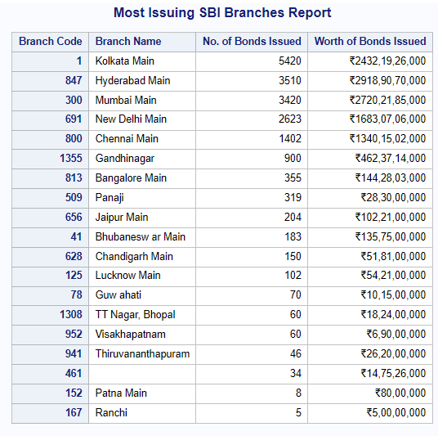

**And Then Taking the count of variable Of Bond Redeeming Branches and sorting them by the Denomination of bonds they issued**

*Rename WORK.BRANCH_CODE_TO_BRANCH_NAME fields;

proc sql;

create table most_issuing_branch as

select t1.Pay_Branch_Code as Branch_Code,

t2.Branch_Name,

count(*) as Total_Count,

sum(input(compress(t1.Denominations, ','), comma20.)) as Total_Denominations

from WORK.REDEEMER_PARTY_ALL_COLS t1

left join WORK.BRANCH_CODE_TO_BRANCH_NAME t2

on t1.Pay_Branch_Code = t2.Branch_Code

group by t1.Pay_Branch_Code, t2.Branch_Name

order by Total_Count desc;

quit;

title "SBI Branches with most Bonds Redeemed Report";

proc print data=most_issuing_branch label noobs;

label Total_Denominations ="Worth of Bonds Redeemed" Total_Count="No. of Bonds Redeemed" Branch_Code="Branch Code";

format Total_Denominations INR_FORMAT.;

id Branch_Code;

run;

